**Project (3)**

|  |  |
| --- | --- |
| Name | Abdurrahman Mohame Elhefnawy |
| Email | Abdurrahman.elhefnwy@gmail.com |

**Automotive door control system design**

# ECU 1

State machine Diagram

Sequence Diagram

# System HyperPeriod

|  |  |
| --- | --- |
| Task | Periodicity |
| Door state | 10 ms |
| Light switch state | 20 ms |
| Speed state | 5 ms |

# CPU load

|  |  |
| --- | --- |
| Task | Execution Time (during 1 hyperperiod) |
| Door state | 1 * 2 ms |
| Light switch state | 1*1 ms |
| Speed state | 1* 4 ms |

# Assume Execution time: task1= task2= task3=1ms

CPU Load = $\frac{Total Execution Time }{Total System Time }$

# CPU Load = $\frac{7}{20}$* 100 = 35%

# ECU 2

State machine Diagram

Sequence Diagram

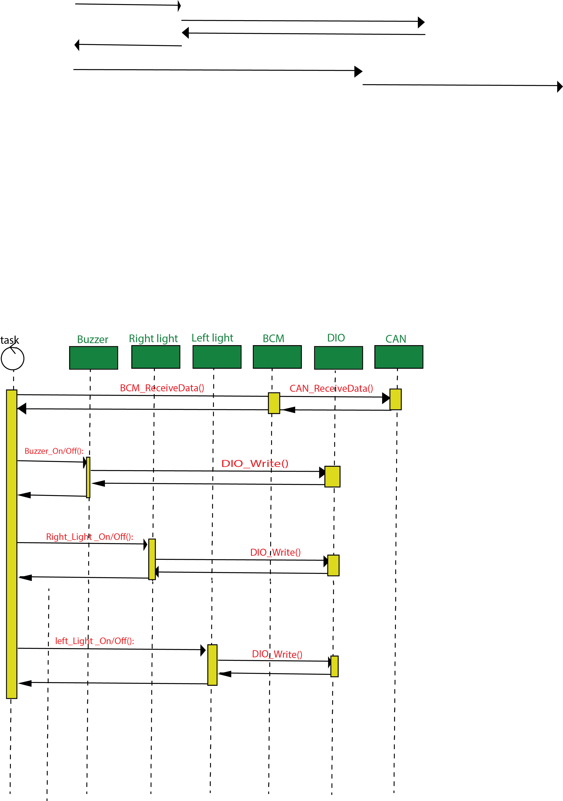

# CPU load

|  |  |
| --- | --- |
| Task | Execution Time (during 1 hyperperiod) |
| Buzzer Controller | 1 * 1 ms |
| Left Light Controller | 1 * 1 ms |
| Right Light Controller | 1 * 1 ms |

# Assume Execution time: task1= task2= task3=1ms

CPU Load = $\frac{Total Execution Time }{Total System Time }$

CPU Load = $\frac{3}{20}$* 100 = 15%